**Liberty University**

**CSIS 331**

**Lab 15 Answer Sheet**

**Packet Tracer – Configure and Verify NTP**

**Complete Address Table:**

|  |  |  |  |
| --- | --- | --- | --- |
| **Device** | **Interface** | **IP Address** | **Subnet Mask** |
| N1 | NIC | 209.165.200.225 | 255.255.255.0 |
| R1 | G0/0 | 209.165.200.226 | 255.255.255.0 |
| R2 | G0/0 | 209.165.200.227 | 255.255.255.0 |

1. Are the clocks synchronized?

Yes. R1 and R2 have the same time as N1.

**Packet Tracer – Configuring Syslog and NTP**

1. Part 2 – Step 2 a – Copy and paste the Syslog events.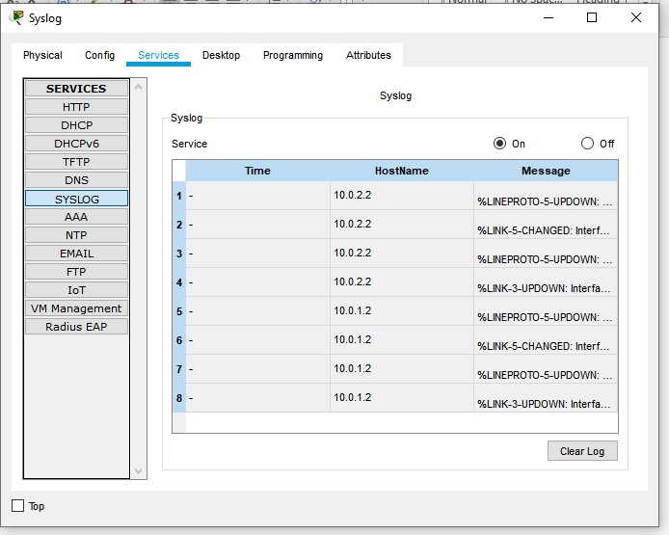
2. Part 4 – Step 1 b – What date and time is displayed?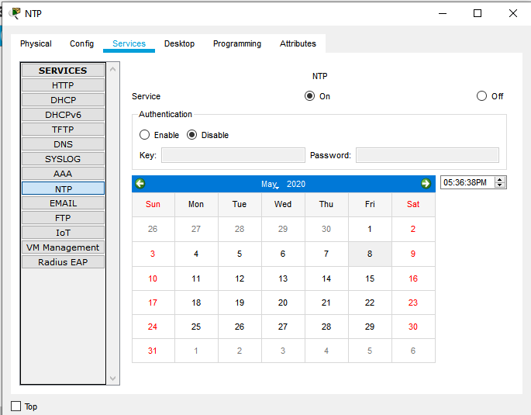
3. Part 5 - Step 2 - Copy and paste Syslog events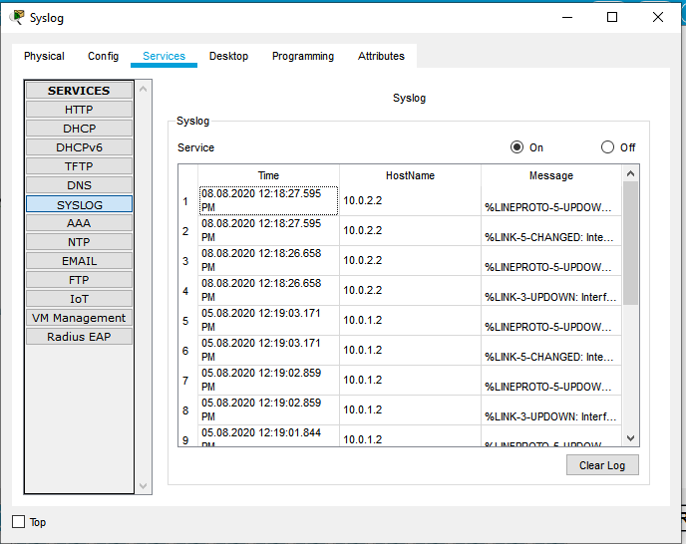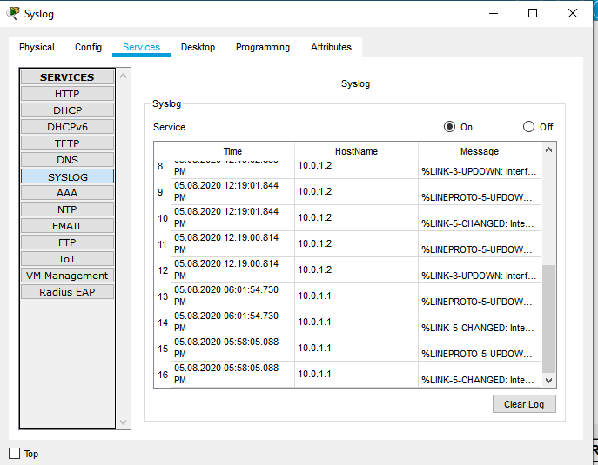

**Packet Tracer – Backing Up Configuration Files**

1. Issue the command to display the current configuration. What changes were made?

Host name

Enable secret

So configuration stored in tftp server loaded in router.

1. Issue the appropriate show command to display the interface status. Are all interfaces active?

G 0/1 is down